الجمهورية اللبنانية
وزارة التربية والتعليم العالي الامتحانات الرسمية لشهادة الامتياز الفني
المديرية العامة للتعليم المهني والتقني لدورة عام 2013 الاولى
الاسم والشهرة:--------------------

رقم المرشح :----------------------
===============
الاختصاص والرمز : المعلوماتية الادارية (24004) –الانظمة والشبكات (24101)
المادة : التطوير التطبيقي بالانترنت – البرمجة بلغة الانترنت المعدل: (8-6)
المستندات المسموح بها : لا شيء المدة : ساعة ونصف

N.B: All the "HTML" files are in the folder: \pages
All the "AUDIO" and "VIDEO" files are in the folder: \pages\files\sounds
All the "IMAGES" files are in the folder: \pages\photo
All others files are in the folder: \pages\files\misc

- Find and correct the six errors in this HTML page:
(3 pts)
<html>
<head>
<meta name="words" content="exams">
<meta name="description" content="exams">
<backgroundsound src="exam.wav" loop="-1">
</head>
<body>
<title>New Page 1</title>
<p align="center"><u><b><font ="7" color="#FF0000">Exams</font></b></p>
<p align="center">&space;</p>
</body>
</html>

II- Write the appropriate tags to obtain as a result the following page " page1.html" respecting the following conditions:  (5 pts)  - The author of the page is “name”  - The Page title is “title”  - The title font size “Online Boutique” is the bigger.  - The font size of the second line is relative smaller by one from the title.  - The title color is red.  - The image name is « imga.jpg »  - Picture size is relative to the half size of the page in width and three quarter in height.  - “image” should be displayed instead of the picture in case of error.  - The video file “movie.mov” should be played 5 times when the mouse passes over the video window. | 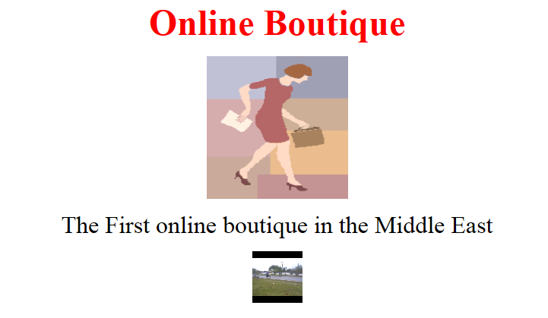
III- Write the appropriate tags to obtain as a result the following page " Catalogue.html" respecting the following conditions:  (5 pts)  - The Table size is 80 % of the page width and 80 % of the page height.  - The border color is green  - The distance between the text in the cells and the border is 4 pixels.  - The distance between the cells is 3 pixels.  - The table is left aligned.  - The image name is “imgb.bmp”. The image has no border.  - The link “bottom” points to the bottom of this page.  - The link “Top” points to the top of this page.  - The link “Download Catalogue” downloads the file “catalogue.doc”. | 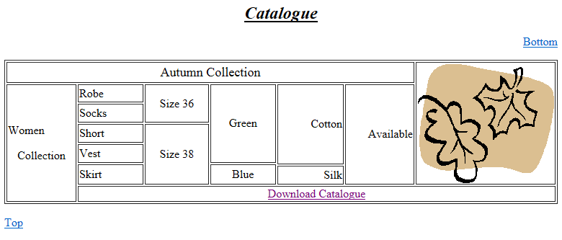

الاسم والشهرة:--------------------

رقم المرشح :----------------------
الاختصاص والرمز : المعلوماتية الادارية (24004) –الانظمة والشبكات (24101)
المادة : التطوير التطبيقي بالانترنت – البرمجة بلغة الانترنت
المستندات المسموح بها : لا شيء

 | IV- Write the appropriate tags to obtain as a result the following page " order.html" respecting the following conditions:  (3 pts)  - Name: Entry field of 20 characters.  - Last Name: Entry field of 20 characters.  - Credit Card Number: Entry field of 20 characters, maximum 16 characters. Stars should be displayed instead of the characters.  - Address: Total characters of this entry field is 50 Characters spread over 4 lines.  - Type: Choice of “Robe”, “Short”, “Vest” and “Skirt”. Only one value can be selected.  - Size: Choice between 2 values “36”and “38”.  - Color: Choice between “Red” , “Blue” and “Green”. Multiple choices can be done. By default Red and Green are selected.  - Receive Email: One box to check.  - The Submit button sends the values to the email address “online@onlineshop.com”.  - A Reset button to restore the default values. | 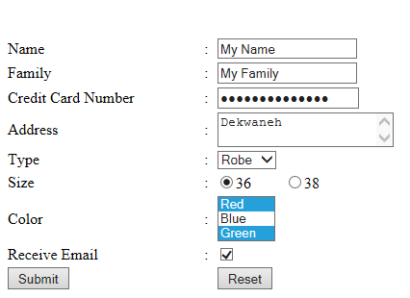
Frame A:
Width: 100 %
Height: 10%
V- Write the appropriate tags to obtain as a result the following page " Index.html" respecting the following conditions  (4 pts)  - This page is divided into 3 frames A, B and C.  - The first frame "A" displays “Created in 2013”.  - The Second Frame “B” Displays by default the page “Page1.html”  - The third frame "C" contains the following links:  - “Main” displays the page “page1.html” in the frame B.  - “Catalogue” displays the page “Catalogue.html” in the frame B.  - “Online Order” displays the page “order.html” in the frame B.  - “google.com” displays the page “google.com” in a new page.  - Create all needed and not exiting pages, and add all needed tags to the previous pages. | 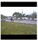  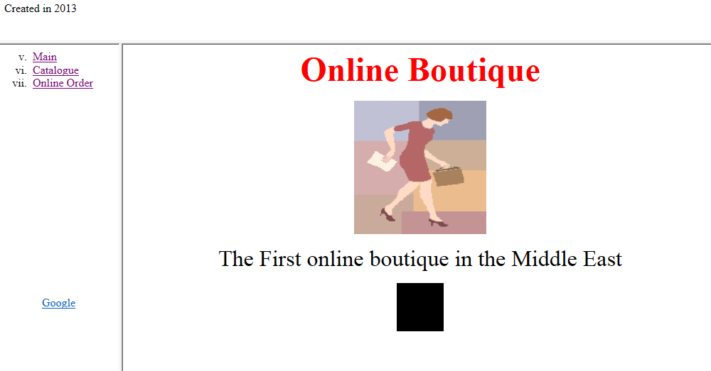
Frame C:
Width 20 %
Height:90%
Frame B:
Width: 80 %
Height: 90%

